SYDNEY WESTERN CITY PLANNING PANEL ASSESSMENT REPORT

Panel Number: | PPSSWC–332
Application Number: | DA/2023/265/1
Local Government Area: | Camden.
Development: | Construction of two x seven storey residential flat buildings over two levels of basement car parking and associated site works including landscaping and engineering works.
Capital Investment Value: | $89,724,182
Site Address(es): | 62 Central Avenue, Oran Park  (Lot 22 DP 270899)
Applicant: | Greenfields Development Company No.2 (GDC) – C/O UrbanCo
Owner(s): | Perich Property Pty Ltd
Date of Lodgement: | 3 June 2023
Number of Submissions: | Nil
Number of Unique Objections: | Nil
Classification: | Regionally Significant Development
Recommendation: | Approve with conditions.
Regionally Significant Development Criteria (Schedule 6 of State Environmental Planning Policy (Planning Systems) 2021): | General development capital investment value >$30 million.
List of All Relevant Section 4.15(1)(a) Matters: | - State Environmental Planning Policy (Planning Systems) 2021.  - State Environmental Planning Policy (Precincts - Western Parkland City) 2021.  - State Environmental Planning Policy (Resilience and Hazards) 2021.  - State Environmental Planning Policy (Biodiversity and Conservation) 2021.  - State Environmental Planning Policy (Building Sustainability Index: BASIX) 2004.  - State Environmental Planning Policy No.65 – Design Quality of Residential Apartment Developments 2002.  - Oran Park Development Control Plan.  - Camden Development Control Plan 2019.
List all Documents Submitted with this Report for the Panel’s Consideration: | - Assessment report.  - State Environmental Planning Policy (Precincts - Western Parkland City) 2021 assessment table.  - Apartment Design Guideline assessment table.  - Oran Park Development Control Plan 2007 assessment table.  - Camden Development Control Plan 2019 assessment table.  - Applicant’s written request seeking to justify the contravention of a development standard.  - Recommended conditions.  - Proposed plans.
Development Standard Contravention Request(s): | Section 4.3 Height of buildings
Summary of Key Submission Issues: | No written submissions were received during the assessment of this development application.
Report Prepared By: | Laura Poulton – Executive Planner
Report Date: | 1 December 2023

Summary of Section 4.15 Matters

Yes
Have all recommendations in relation to relevant Section 4.15 matters been summarised in the Executive Summary of the assessment report?

Legislative Sections Requiring Consent Authority Satisfaction

Yes
Have relevant sections in all applicable environmental planning instruments where the consent authority must be satisfied about a particular matter been listed and relevant recommendations summarised in the Executive Summary of the assessment report?

Development Standard Contraventions

 | Yes | N/A
If a written request for a contravention to a development standard has been received, has it been attached to the assessment report?

Special Infrastructure Contributions

 | Yes | No
Does the application require Special Infrastructure Contributions?

Conditions

Yes
Have draft conditions been provided to the applicant for comment?

Purpose of Report

The purpose of this report is to seek the Sydney Western City Planning Panel’s (the Panel’s) determination of a development application (DA) for the construction of two x seven storey residential flat buildings with associated site works at 62 Central Avenue, Oran Park (refer to Figure 1 below).

The Panel is the consent authority for this DA as the capital investment value (CIV) for the development is $89,724,182. This exceeds the CIV threshold of $30 million for Council to determine the DA, pursuant to Schedule 6 of the State Environmental Planning Policy (Planning Systems), 2021.

Summary of Recommendation

That the Panel determine DA/2023/265/1 for the construction of two x seven storey residential flat buildings with associated site works pursuant to Section 4.16 of the Environmental Planning and Assessment Act, 1979, by granting consent, subject to the conditions attached to this report.

Executive Summary

Council is in receipt of a DA for the construction of two x seven storey residential flat buildings with associated site works at 62 Central Avenue, Oran Park (see Figure 1 below). The DA has been assessed against the Environmental Planning and Assessment Act, 1979, the Environmental Planning and Assessment Regulation, 2021, relevant environmental planning instruments, development control plans and policies. A summary of the assessment against all relevant environmental planning instruments is provided below.

Policy | Summary
State Environmental Planning Policy (Planning Systems) 2021 | Pursuant to Schedule 6 of this policy, the Regional Planning Panel is the consent authority for this DA as the development has a CIV threshold of $89,724,182. The CIV threshold for Council to determine the DA is $30 million.
State Environmental Planning Policy (Precincts – Western Parklands City) 2021 (Precincts SEPP) | The site is situated within the Oran Park Precinct area and forms part of the Oran Park Town Centre. The site is subject to the relevant matters contained in Appendix 2 Oran Park and Turner Road Precinct Plan of the Precincts SEPP. The development proposes a contravention to Section 4.3 Height of Buildings pursuant to Section 4.6 Exceptions to Development Standards of the Precincts SEPP. Specifically, the development site is subject to a maximum building height control of 24m. The development (as proposed) seeks a maximum building height of 25.8m, exceeding the development standard by 1.8m (or 7.5%). A detailed assessment against Section 4.6 of the SEPP is provided below and as a separate attachment to this report.  A detailed assessment against all other relevant matters contained in this policy is also provided as an attachment to this report.  Subject to the above-noted non-compliance, the development is generally consistent with all relevant matters contained in the Precincts SEPP.
State Environmental Planning Policy (Resilience and Hazards) 2021 (Resilience and Hazards SEPP) | Information available to Council confirmed that during the rezoning phase of the wider precinct area, no areas of concern were identified specifically within the development site. Further, no areas of concern were discovered whilst the earthworks were carried out in accordance with the parent bulk earthworks and subdivision DA approval (refer to site history below).  As the development site is vacant and has not been occupied by any other land uses, it is unlikely the development site has been exposed to any contaminated soils and/or other substances which may affect the suitability of the site for the proposed development with regards to contamination. Douglas Partners have reviewed the subject site and have advised that the site is suitable for the proposed development, subject to carrying out the Unexpected Finds Protocol in the event that any unexpected finds are established during the construction phase.  The application has been reviewed by Council’s Environmental Health Officer, who raised no objection to the proposal subject to standard conditions to ensure the development is carried out in accordance with the recommendations in the report (prepared by Douglas Partners).
State Environmental Planning Policy (Biodiversity and Conservation) 2021 (Biodiversity and Conservation SEPP). | The development is considered satisfactory in terms of the matters for consideration in Chapter 6 of the Biodiversity and Conservation SEPP.
State Environmental Planning Policy (Building Sustainability Index: BASIX) 2004 (BASIX SEPP) | A BASIX Certificate and Capability Report has been submitted with the DA, noting that all proposed residential units will achieve the relevant targets under the BASIX SEPP. Standard conditions are recommended to ensure ongoing compliance with this policy.
State Environmental Planning Policy No 65 – Design Quality of Residential Apartment Development 2002 (SEPP 65) | As the development proposes two residential flat buildings, an assessment of the relevant provisions contained in this policy and the Apartment Design Guideline (ADG) have been undertaken. The assessment has determined that the development is generally consistent with the relevant matters contained in this policy and the ADG.

The DA was publicly exhibited for a period of 28 days from 30 May 2023 to 26 June 2023. No written submissions were received during this time and/or during the assessment of the DA.

The development seeks a contravention to the Height of Buildings development standard, pursuant to Section 4.3, Appendix 2 Oran Park and Turner Road Precinct Plan of State Environmental Planning Policy (Precincts – Western Parklands City) 2021 (Precincts SEPP). The development proposes a maximum building height of 25.8m, exceeding the development standard by 1.8m (or 7.5%). The variation is sought to accommodate the lift risers on the rooftop level and small sections of the roof area.

It is noted that the development is consistent with the seven-storey building height requirement, prescribed under Part B1 Oran Park Town Centre (Part B1) of the Oran Park Development Control Plan (Oran Park DCP). In addition, the development has been designed with consideration of the vision and development objectives also prescribed in Part B1 of the Oran Park DCP, which therefore ensures the development is consistent with the overall masterplan set out for the precinct. As assessment against Section 4.6 Variation to a Development Standard has been undertaken, which has determined that compliance with the development standard is unnecessary and unreasonable as the extent of the variation is relatively minor and there will be no/minimal adverse impacts to the site and surrounding land uses.

With the exception of the above, the development is generally compliant with all other relevant planning controls. Based on the assessment, it is recommended that the DA be approved subject to the conditions of this report.

Key Planning Control Variations

Control | Proposed | Variation
24m maximum building height | 25.8m | 1.8m (or 7.5%).

Aerial Photo

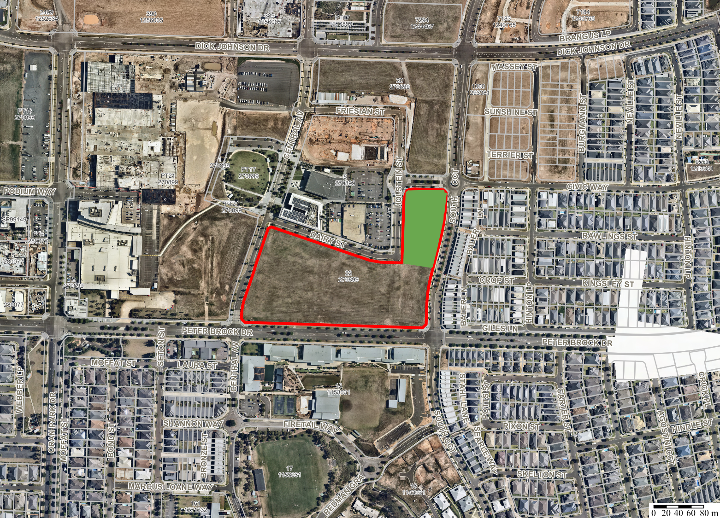
DA/2023/265/1
Aerial
 | Subject Site:  62 Central Avenue ORAN PARK  LOT: 22 DP: 270899

Figure 1 – The site is outlined in red. The development site is coloured in green.

the Site

The site comprises of a single lot that is commonly known as 62 Central Avenue, Oran Park and is legally described as Lot 22 in DP270899 (as shown in Figure 1 above). Specifically, the development site is located on the north-western portion of the superlot and forms part of the Oran Park Town Centre. The development site is bounded by South Circuit to the east, Civic Way to the north and Holstein Street to the west. An extension to Dairy Street has been approved to run along the southern boundary of the subject development site however has yet to be constructed. The site has a cross fall of approximately 1.2m from the north-eastern to the south-western corner and is not flood affected or bushfire prone.

The development site is located on the eastern edge of the Oran Park Town Centre, which forms part of the South West Growth Centre. Since the rezoning, the Oran Park Town precinct has delivered over 4,000 residential homes as well as other commercial and retail premises including Stage 1 and 3 of Oran Park Podium further west from the development site. As shown in Figure 2 and 6 below, the site is also located in proximity to a number of key land uses that also form part of the Town Centre including the future train station, Town Square (west), Town Park (west), the Leisure Centre (northwest) and future large-scale commercial developments (south and south-west).

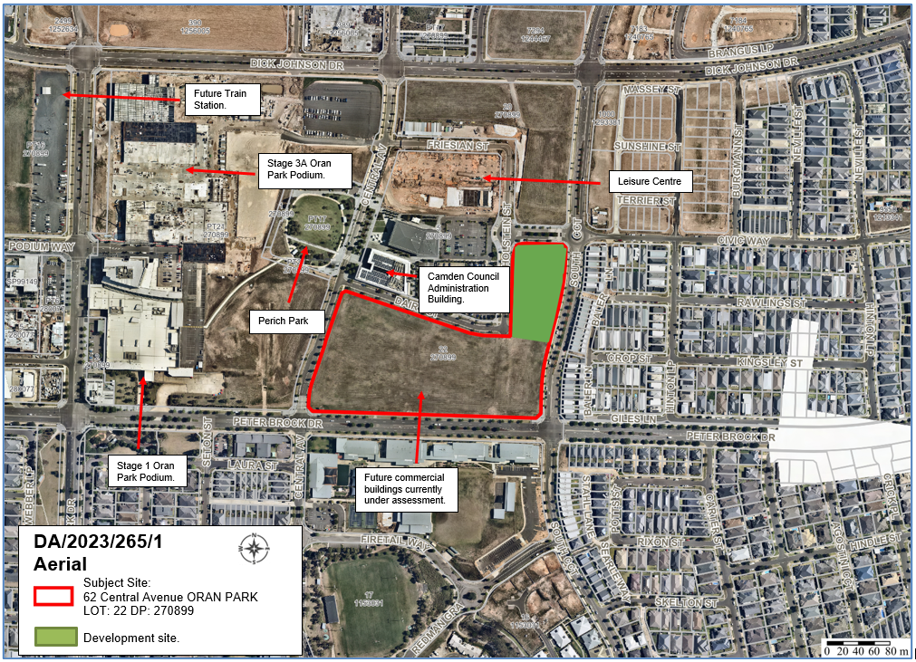
Figure 2 – The subject site (outlined in red) and surrounding key land uses.

The development site is zoned B2 Local Centre (refer to Figure 4 below) pursuant to Appendix 2 Oran Park and Turner Road of the Precincts SEPP. The site and surrounding allotments are subject to a maximum building height control of 24m, pursuant to Clause 4.3 of the Precincts SEPP (refer to Figure 5 below).

DA/2023/556/1 is currently under assessment by Council staff for two x six-storey commercial buildings which are proposed on the southern end of the parent site (refer Figure 3 below). A DA has yet to be lodged for the future commercial development immediately south of the development site (as shown in Figure 3).

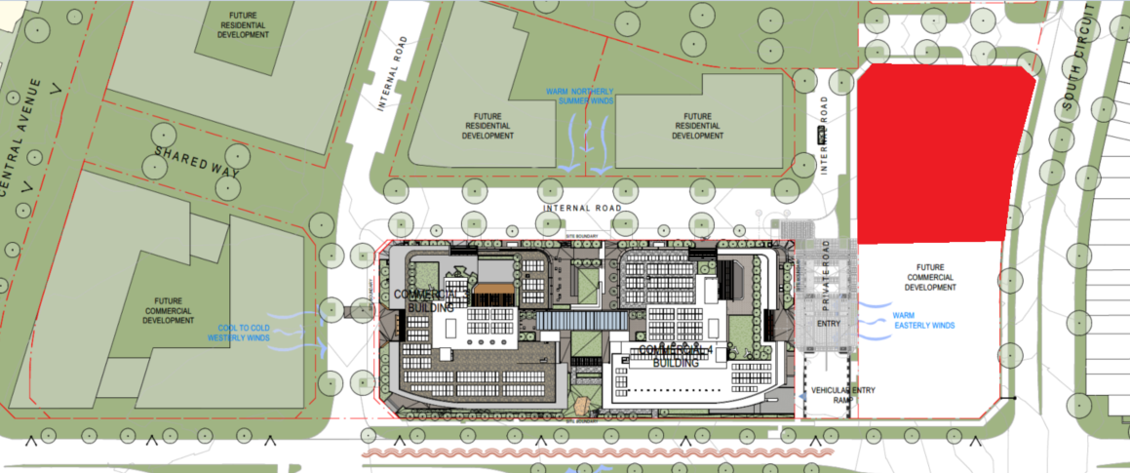
Figure 3 – Site plan of the proposed commercial building which is currently under assessment by Council staff. The development site associated with DA/2023/265/1 is coloured in red.

Zoning Plan

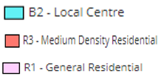
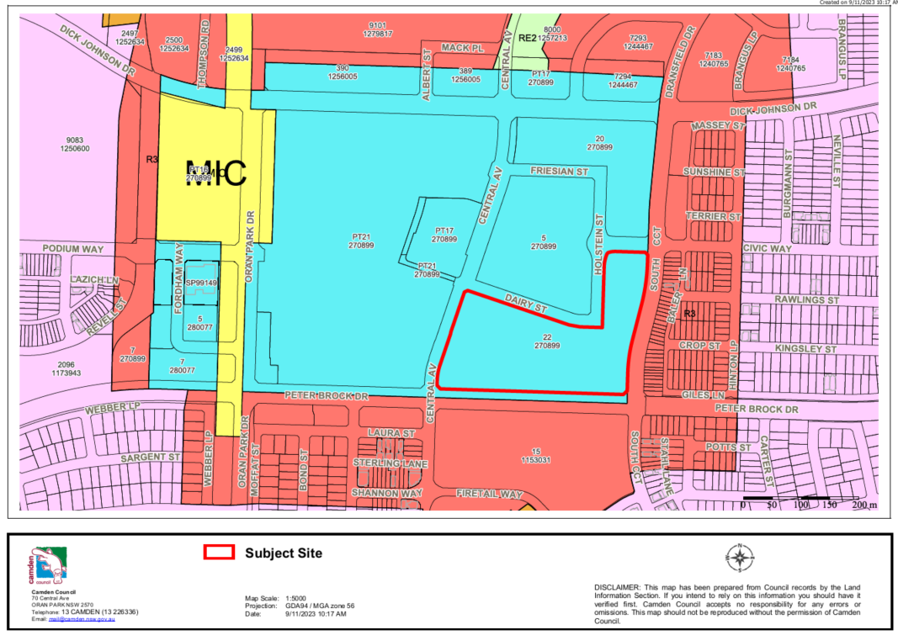
Figure 4 – Land zoning map of the site and surrounding allotments. The site (outlined in red) and surrounding allotments.

HEIGHT OF BUILDING MAP

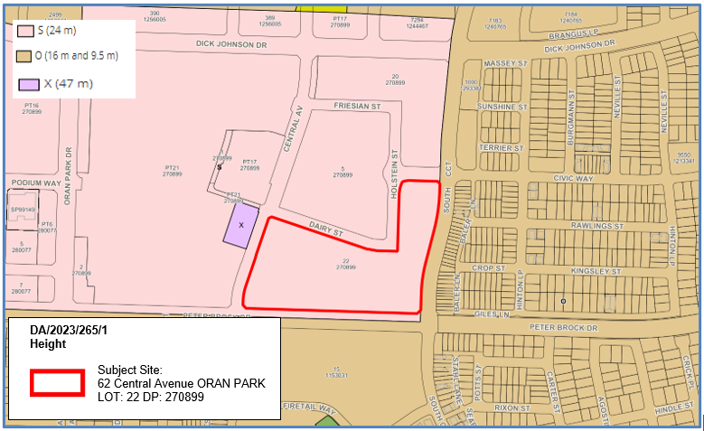
Figure 5 – Height of Buildings map. The site is outlined in red.

AREA MASTER PLAN

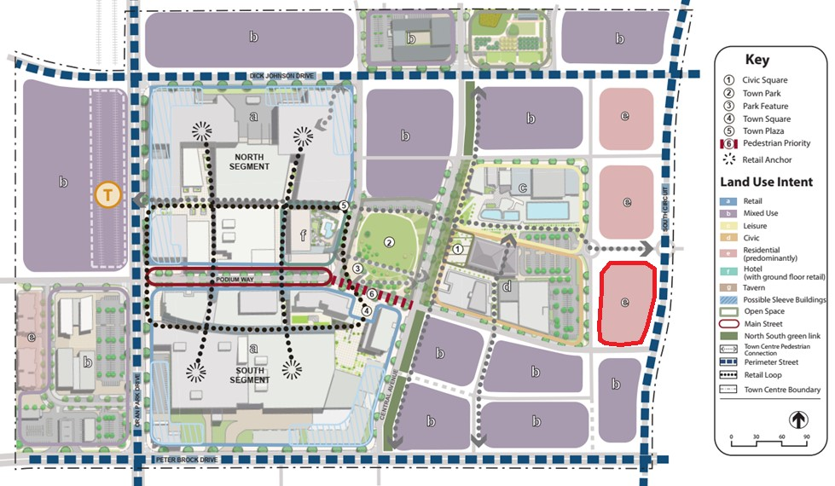
Figure 6 – Masterplan of the Oran Park Town Centre. The site is outlined in red.

HISTORY

The relevant development history of the site is summarised in the following table:

Date | Development
DA/2010/1548/1 | Bulk earthworks and remediation of contaminated land. These works were carried out over the subject site. This DA was approved by Council staff on 30 June 2011.  Relevance: Carried out over the development site.
DA/2017/1525/1 | Subdivision to create two lots and construction of local roads. This DA was approved by Council staff on 10 May 2018.  Relevance: The subdivision created the subject lot containing the proposed development.
DA/2022/626/1 | Construction of the Dairy Street extension, including the dedication of road, provision of a Community Title Subdivision to create three lots and associated site works. This DA was approved by Council staff on 3 April 2023.  Relevance: The road will allow for driveway access into the development site.
DA/2023/556/1 | Staged construction of two six-storey commercial buildings comprising three levels of basement carparking and associated site works. This proposal is located on the southern end of the site. This DA has yet to be determined by the Regional Planning Panel.  Relevance: The proposed development subject to DA/2023/556/1 is located on the southern end of the site.

THE PROPOSAL

DA/2023/45/1 seeks approval for the construction of two x seven storey residential flat buildings erected above two levels of basement car parking and associated site works.

Specifically, the development application (DA) includes the following works:

- Erection of Building 3A (north), comprising of seven storeys, containing 66 units with a mix of one, two and three bedroom apartments.
- Erection of Building 3B (south), comprising of seven storeys, containing 111 units with a mix of one, two and three bedroom apartments.
- Two levels of basement car parking, comprising of 277 car parking spaces, 15 motorcycle spaces, 63 bicycle spaces, two car washing bays and storage rooms.
- Associated site works including landscaping and drainage works.

A site plan of the proposed development is shown below in Figure 7.

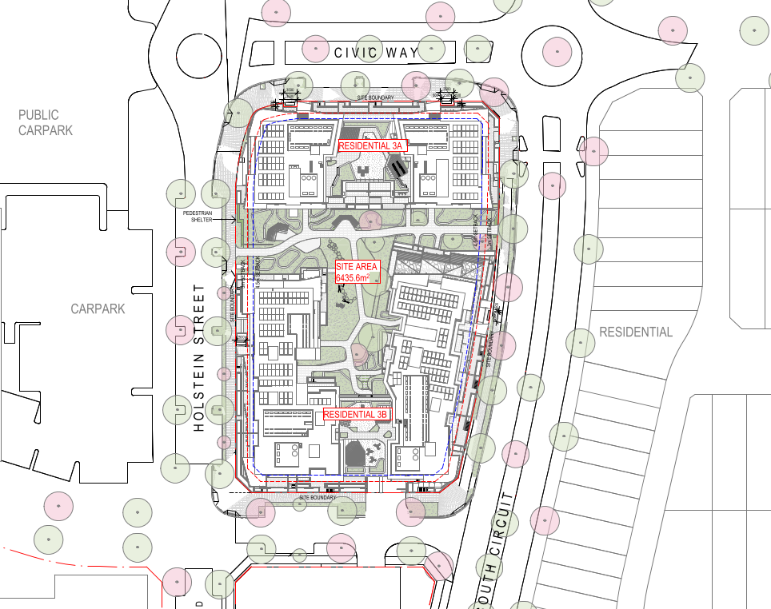
Figure 7 – Proposed site plan.

PANEL BRIEFING

A preliminary briefing was held with Council staff and the applicant on 5 June 2023. The following comments were made by the Panel in regard to the proposed development:

Comment: The Panel was assured that general overall compliance with the Apartment Design Guidelines (ADG) would be achieved, particularly in terms of building separation, common open space and solar access to common open space areas.

Response: Since the lodgement of this DA, amended architectural plans have been submitted, demonstrating the development (as proposed) is compliant with the Apartment Design Guideline (ADG). Specifically, it can be confirmed that:

- The development proposes a minimum separation distance (between Building A and Building B) of 12m on the Ground Level and Levels 1, 2 and 3 and 18m on Levels 4, 5 and 6. In addition to this, privacy screens are proposed where there is potential for direct overlooking into habitable rooms and/or private open space areas. Overall, the proposed separation distance is considered appropriate.
- The proposal achieves sufficient solar amenity to habitable rooms, private open space and communal open space areas in accordance with the ADG.
- The development exceeds the minimum required communal open space area across the development site.

Overall, it is considered that the development achieves a good design outcome for the site and future residents. Consequently, the adverse impacts of the development to the site and surrounding land uses are minimal.

A detailed assessment against the ADG is provided as a separate attachment to this report, which demonstrates that the development is largely compliant.

Comment: The Panel noted the volume of the southern building and would need to be satisfied with appropriate architecture and detailing that the design will have an acceptable presentation to the surrounding area.

Response: The development site forms part of the Oran Park Town Centre which consists of higher scale urban development (see Figure 4 above and Figure 8 below). As such, the bulk and scale of the development is generally consistent with other developments existing, approved and anticipated within the immediate vicinity of the site.

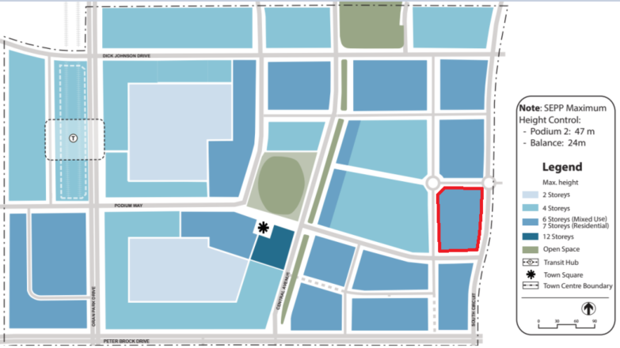
Figure 8 – Indicative Building Heights in the Oran Park Town Centre.

Amended architectural plans have since been provided which include additional articulation and featured architectural elements to the building entries in order to ensure they are visibly recognisable via the public domain. In addition, planter beds have been included to reduce the dominance of the brick walls along the streetscape edges. Some of the changes made to the buildings are outlined in Figures 9-12 below.

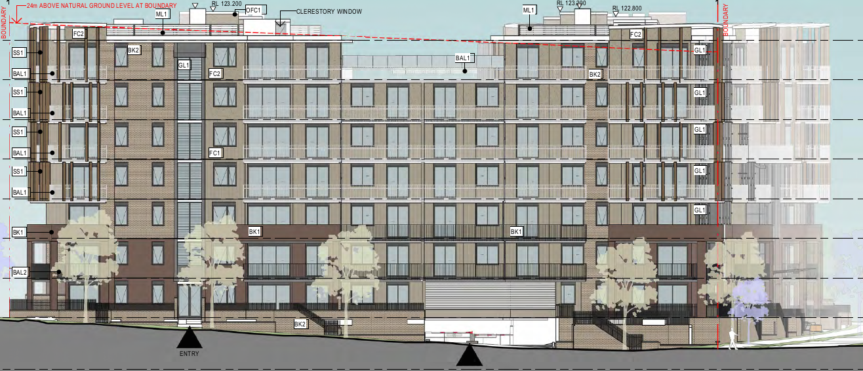 | 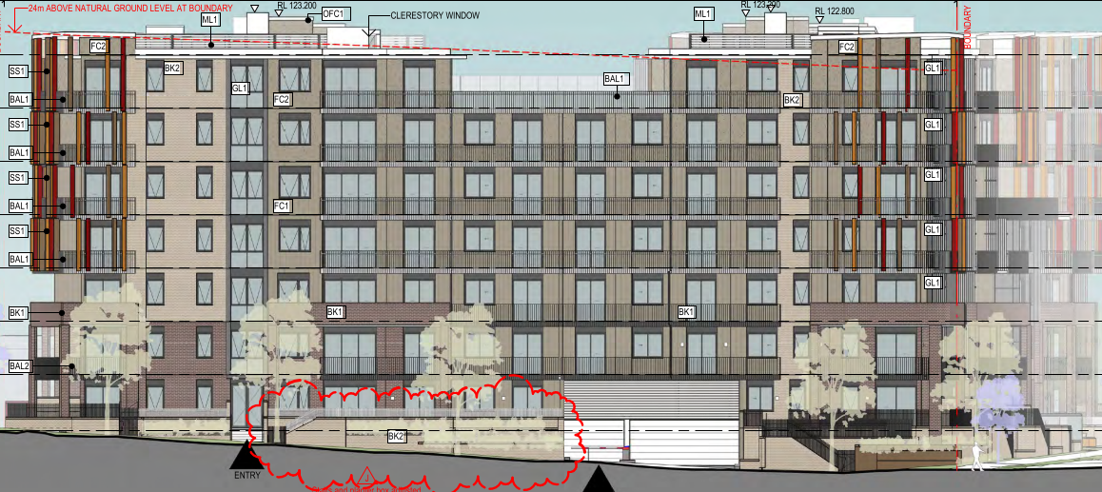
Figure 9 – Original Northern Elevation (Building A). | Figure 10 – Revised Northern Elevation (Building A).
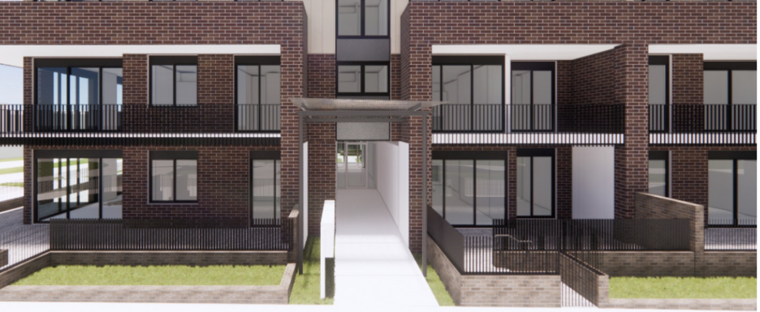
Figure 11 – Photomontage of the initial entry treatment proposed.

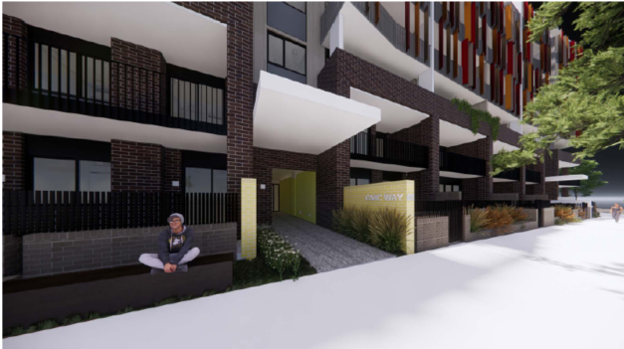
Figure 12 – Photomontage of the revised entry treatment.

ASSESSMENT

Environmental Planning and Assessment Act 1979 - Section 4.15(1)

In determining a DA, the consent authority is to take into consideration such of the following matters as are of relevance to the development the subject of the DA:

(a)(i) the provisions of any environmental planning instrument

The environmental planning instruments that apply to the development are:

- State Environmental Planning Policy (Planning Systems) 2021.
- State Environmental Planning Policy (Precincts - Western Parkland City) 2021.
- State Environmental Planning Policy (Resilience and Hazards) 2021.
- State Environmental Planning Policy (Biodiversity and Conservation) 2021.
- State Environmental Planning Policy No. 65 Design Quality of Residential Apartment Development 2002.
- State Environmental Planning Policy (Building Sustainability Index: BASIX) 2004.

State Environmental Planning Policy (Planning Systems) 2021 (Planning Systems SEPP)

The Planning Systems SEPP identifies development that is state significant development, infrastructure and critical infrastructure and regionally significant development.

The Panel is the consent authority for this DA as the CIV of the development is $89,724,182 and is therefore classed as regionally significant development. The CIV threshold for Council to determine the DA is $30 million pursuant to Schedule 6 of the Planning Systems SEPP.

State Environmental Planning Policy (Precincts - Western Parkland City) 2021 (Precincts SEPP)

The Western Parkland City SEPP aims to co-ordinate the release of land for residential, employment and other urban development in the North West Growth Centre, the South West Growth Centre, the Wilton Growth Area and the Greater Macarthur Growth Area.

The development site is subject to the relevant matters contained under Appendix 2 Oran Park and Turner Road Precinct Plan of the Precincts SEPP. A detailed assessment of the subject proposal against all relevant matters contained in the Precincts SEPP is provided as a separate attachment to this report.

Site Zoning

The site is zoned B2 Local Centre pursuant to Section 2.2, Appendix 2 of the Precincts SEPP (refer to Figure 4 above).

Development Characterisation and Permissibility

The development is characterised as a ‘residential flat building’ by the Precincts SEPP. The proposal is permissible with development consent in the B2 Local Centre zone, pursuant to the Precincts SEPP.

Planning Controls

An assessment table in which the development is considered against the Precincts SEPP’s planning controls is provided as an attachment to this report.

Proposed Contravention – Clause 4.3 Height of buildings

The applicant proposes a contravention to the height of buildings development standard that applies to the site. The development standard limits buildings to a maximum height of 24m above finished ground level (as shown in Figure 5 above). The development proposes a maximum height of 25.8m above finished ground level, contravening the development standard by 1.8m (or 7.5%).

The variation is sought to accommodate the lift risers on the rooftop and small sections of the roof area only (refer Figure 13 below). The extent of the variation is also shown in the elevation plans which is provided as a separate attachment to this report. Whilst a variation to the building height is sought, it is noted that the proposed number of storeys is consistent with the adopted masterplan for the Oran Park Town Centre and the seven-storey height nominated in the Oran Park DCP (refer to Figure 8 above).

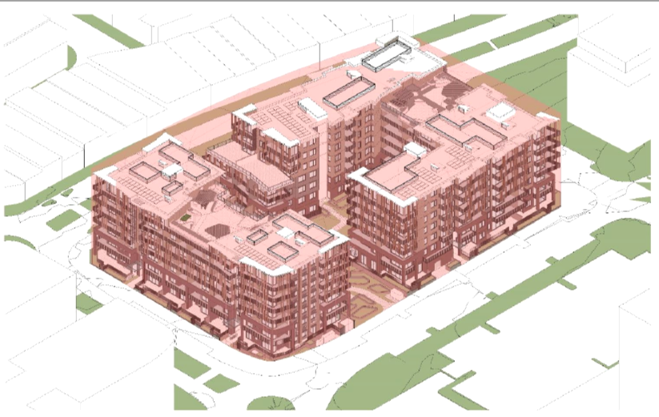
Figure 13 – Proposed buildings associated with this DA. Areas of the building that are coloured in pink are contained within the 24m height limit. Areas coloured in white of the building are where the variations are sought to the building height.

Contravention Assessment

On 1 November 2023, amendments were made to the standard Section 4.6 relating to variations to development standards across all applicable environmental planning instruments. Pursuant to Section 2.45 State Environmental Planning Policy Amendment (Exceptions to Development Standards) 2023 (SEPP Amendment), a Development Application made but not yet determined before the commencement of the SEPP Amendment must be determined as if the policy had not commenced. As such, the DA will be assessed against the original Section 4.6 provisions.

Section 4.6(3) states that development consent must not be granted for a development that contravenes a development standard unless the consent authority has considered a written request from the applicant that seeks to justify the contravention of the development standard by demonstrating:

- the applicant’s written request has adequately addressed the matters required to be demonstrated by Appendix 2, Section 4.6(3) of the Precincts SEPP, and

- the development will be in the public interest because it is consistent with the objectives of the particular standard and the objectives for development within the zones in which the development is proposed to be carried out.

In accordance with Section 4.6(3), the applicant requests that the height of buildings development standard be varied. The applicant’s written request is attached to this report which addresses why the compliance is unreasonable and unnecessary in the particular circumstances of the case and outlines the following key environmental planning grounds to justify contravening the development standard for the following reasons:

- The variation relates to the lift risers on the rooftop and small sections of the roof area only. It is therefore justified that the extent of the variation is relatively minor and therefore the adverse impacts to the site and surrounding land uses will be minimal.

- The small section of roof elements which exceeds the building height will not be visible from the pedestrian scale ground level viewscapes.

- The proposed development remains consistent with the vision for the wider Oran Park Town Centre and key planning controls relating to building heights, scale and building form prescribed under Part B1 of the Oran Park DCP.

- The proposed rooftop air conditioning condenser will eliminate the need for balconies and/or courtyards to contain air conditioner units, which will enhance the overall building presentation, increase the useable area within the allocated private open space areas and reduce the overall acoustic impacts between units.

- The provision of skylight windows on the rooftop level enhances internal solar access and ventilation to units.

Council Staff Assessment

Pursuant to Appendix 2, Section 4.6(4) of State Environmental Planning Policy (Precincts-Western Parkland City) 2021, Council staff are satisfied that:

- The applicant’s written request has adequately addressed the matters required to be demonstrated by Appendix 2, Section 4.6(3) of the Western Parkland City SEPP; and
- The development will be in the public interest because it is consistent with the objectives of the particular standard and the objectives for development within the zone in which the development is proposed to be carried out.

The development standard contravention is supported for the following reasons:

- The development is consistent with the objectives of the development standard:

- To preserve the amenity of adjoining development in terms of solar access to dwellings, private open space and bulk and scale.

Comment: The buildings have been designed with consideration of surrounding developments proposed and/or developments under construction within the wider Oran Park Town Centre. Specifically, it is noted that:

- The development meets the minimum requirements with regards to solar amenity to private and communal open space areas.
- The development will have no adverse solar amenity impacts to surrounding and future land uses.
- The development is consistent with the overall bulk and scale envisioned for the Oran Park Town Centre. Further, the development proposes a maximum of seven storeys which is consistent with the masterplan and key planning controls prescribed under Part B1 of the Oran Park DCP.
- Sufficient building separation distances and/or privacy screens (where applicable) have been established across the development site to ensure there are no adverse privacy impacts within the site. In addition, a minimum distance of 37m is proposed to the nearest PPOS area on the adjoining residential allotments (to the east). As such, the development is unlikely to cause privacy issues on surrounding allotments.

In addition to the above, a number of developments have been approved within the Town Centre, that have exceeded the maximum building height development standard prescribed under Section 4.3 of the Precincts SEPP. These developments have successfully demonstrated that, despite the height contravention, they will add positively to the character of the Oran Park Town Centre. Some nearby examples are provided below.

DA/2017/1526/1 – Construction of a six-storey commercial building, basement level car parking and associated site works and landscaping. The development approved a total building height of 28.15m.

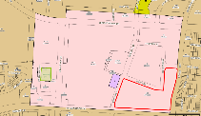
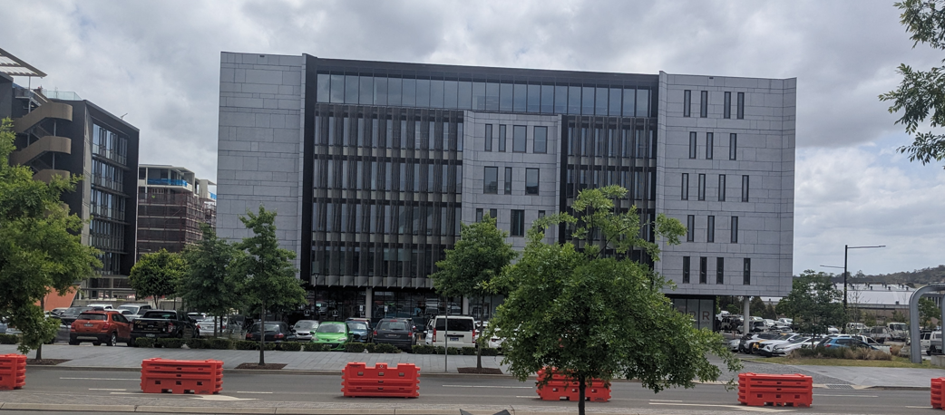
Figure 14 – Commercial building associated with the above approval. In the map, the site is outlined in red whereas the development site is outlined in green.

DA/2019/269/1 – Construction of a six-storey commercial building with three levels of basement car parking and associated site works including landscaping, civil works and earthworks. The development approved a total building height of 28.85m.
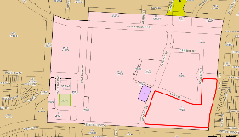
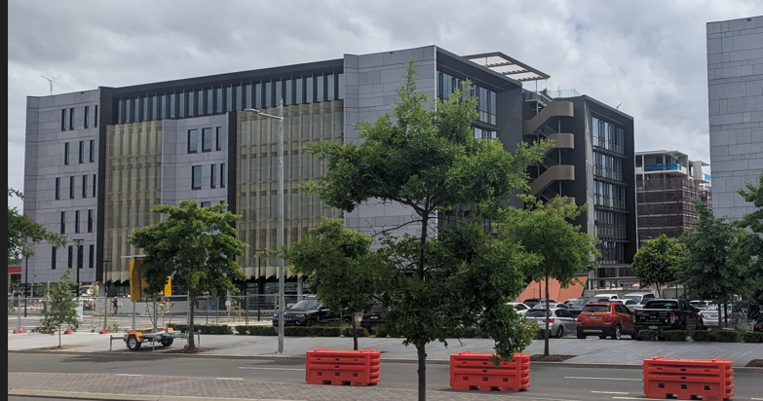
Figure 15 – Commercial building associated with the above approval. In the map, the site is outlined in red whereas the development site is outlined in green.

DA/2018/1223/1 – Staged extension of Oran Park Podium Shopping Centre. Stage 1 includes extension of Oran Park Podium Shopping Centre retail space, construction of one residential flat building (five storeys above the retail space), construction of one commercial building (four storeys above the retail space), extension of basement car park, extension of Main Street. Stage 2 includes concept approval for building envelopes of two residential flat buildings. The development was approved with a maximum building height of 28m.

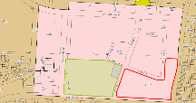
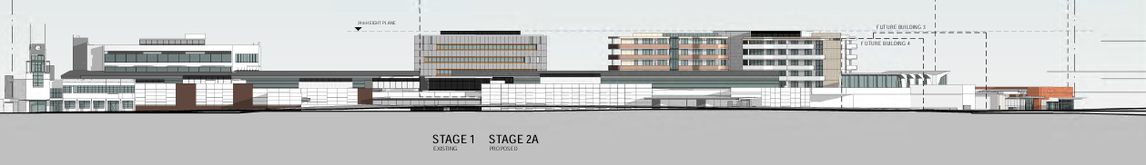
Figure 16 – Approved southern elevation associated with the above approval. In the map, the site is outlined in red whereas the development site is outlined in green.

DA/2023/556/1 – Staged construction of two, six storey commercial buildings comprising of three levels of basement car parking and associated site works. The development is yet to be approved however does propose a maximum building height of 26m (approximately). The development is proposed on the southern end of the subject development site.

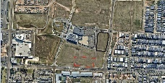
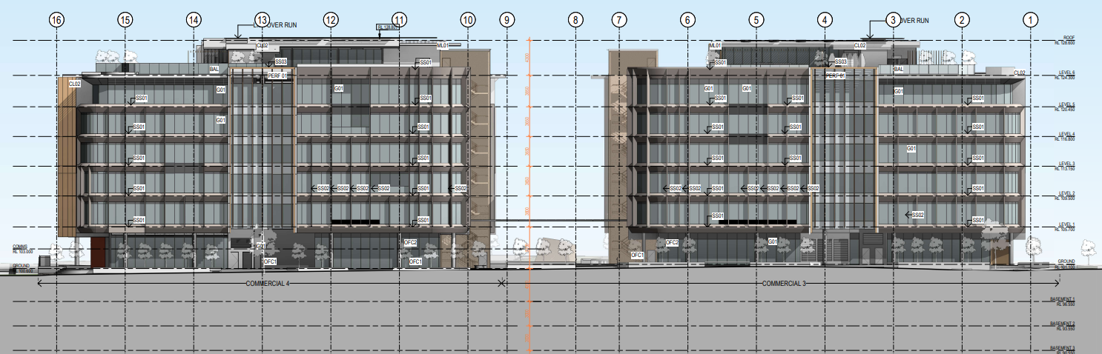
Figure 17 – Northern elevation of the proposed development. In the map, the site is outlined in black. The proposed development is outlined in red.

- To provide for a range of residential building heights in appropriate locations that provide a high-quality urban form.

Comment: All lots within the Oran Park Town Centre are subject to a maximum building height control of 24m as per Section 4.3 of the Precincts SEPP (with an exception of a small portion on the southern end of Perich Park, which is subject to a maximum building height of 47m). Further, the site and surrounding allotments are also subject to a seven-storey height limit which has been prescribed in the Oran Park DCP. The proposed building height contravention is primarily caused by ancillary structures on the building and therefore the proposal still delivers a perceived height that is in context for the site and the wider Oran Park Town Centre area.

- To facilitate higher density neighbourhood and town centres while minimising impacts on adjacent residential areas.

Comment: The proposal has been designed with consideration of the adjoining integrated residential development (on South Circuit) in that ensuring private and communal open space areas (within the development site) will not cause privacy and/or acoustic impacts for these adjoining allotments. All other adjoining allotments are envisioned for commercial and retail purposes.

- To provide appropriate height controls for commercial and industrial development.

Comment: This objective is not relevant as the development is for residential purposes only.

- The development is consistent with the objectives for development within the zones in which the development is proposed to be carried out:

B2 Local Centre

To provide a range of retail, business, entertainment and community uses which serve the needs of people who live in, work in and visit the local area.

Comment: The development is for the purpose of residential accommodation only. The provision of residential apartments in the proposed location will provide residents with the opportunity to live within the Town Centre, which also consists of various land uses including Oran Park Podium, higher density commercial buildings (under construction, approved and/or already operating), various types of educational establishments including Oran Park Anglican College and child care centres) and community land uses including Oran Park Leisure Centre (under construction) and Perich Park.

To encourage employment opportunities in accessible locations.

Comment: The development proposes residential units on the eastern boundary of the Town Centre which consist of various types of commercial and retail land uses. The development will deliver pedestrian pathways that will connect to adjoining land uses including Oran Park Library, Perich Park and the future Podium Way expansion which is envisioned as the key pedestrian priority link in the Oran Park Town Centre masterplan. The proposed development is therefore in an accessible location to key employment opportunities in the Town Centre.

To maximise public transport patronage and encourage walking and cycling.

Comment: The development is located in the immediate vicinity of key public transport networks including bus services and the future railway station. The development will therefore encourage future residents to use public transport as it is easily accessible.

To ensure that residential development does not detract from the primary function of the centre being to provide for retail, business, entertainment and community uses.

Comment: The development is located on the eastern boundary of the Town Centre. The development will provide pedestrian pathways around the site, that will connect to adjoining land uses. Further, ground level courtyards and balconies are proposed on all elevations, which will contribute to passive surveillance. This will encourage regular pedestrian activity within and around the site, therefore contributing to the overall vitality of the area. The development will not detract from the primary function of the Town Centre.

To ensure that residential development does not preclude the provision of active uses at street level.

Comment: For ground floor apartments, courtyards are proposed which will allow for direct access onto the street. In addition to this, there is direct access to the communal open space area (on the ground floor) via the public domain. As such, these design elements will further encourage pedestrian activity around the site, therefore contributing to passive surveillance.

To provide for land uses of a higher order and density within the Local Centre Zone than are permitted within the Neighbourhood Centre Zone or the Mixed-Use Zone.

Comment: The development is for the purpose of a residential flat building, which is of a higher scale land use. The proposed land use is located on the eastern boarder of the Oran Park Town Centre, therefore providing residents opportunities to live closer to a range of employment opportunities and other key services such as all types of educational establishments and medical services.

To provide for residential development that contributes to the vitality of the local centre.

Comment: The development will add to the level of pedestrian activity within and around the development site and around the Oran Park Town Centre, contributing to the vitality of the area.

As noted above, the proposal results in a preferable outcome for the site, compared to a strictly compliant scheme. The proposal is generally consistent with other built forms (existing, approved and/or constructed) within the Oran Park Town Centre, contributing to the vision and development objectives set for the area. In addition, the application has been reviewed by Council’s Design Review Panel and internal Urban Design Advisor, both of whom were supportive of the scheme, subject to the imposition of recommended conditions of consent.

It is noted that the Panel may assume the concurrence of the Secretary pursuant to Planning Circular PS 20-002.

Consequently, it is recommended that the Panel support this proposed contravention to Section 4.3 of the Western City Parkland SEPP.

State Environmental Planning Policy (Resilience and Hazards) 2021 (Resilience and Hazards SEPP)

The Resilience and Hazards SEPP regulates hazardous and offensive development and aims to ensure that the consent authority has sufficient information to assess whether or not development is hazardous or offensive. The Resilience and Hazards SEPP also provides a Statewide planning approach to the remediation of contaminated land.

Section 4.6 of the Resilience and Hazards SEPP requires the consent authority to consider if the site is contaminated. If the site is contaminated, the consent authority must be satisfied that it is suitable in its contaminated state for the development. If the site requires remediation, the consent authority must be satisfied that it will be remediated before the land is used for the development. Furthermore, the consent authority must consider a preliminary contamination investigation in certain circumstances.

Information available to Council confirmed that during the rezoning phase of the wider precinct area, no areas of concern were identified specifically within the development site. Further, no areas of concern were discovered whilst the earthworks were carried out in accordance with the parent bulk earthworks and subdivision DA approval (refer to site history below).

As the development site is vacant and has not been occupied by any other land uses, it is unlikely the development site has been exposed to any contaminated soils and/or other substances which may affect the suitability of the site for the proposed development with regards to contamination. Douglas Partners have reviewed the subject site and have advised that the site is suitable for the proposed development, subject to carrying out the Unexpected Finds Protocol in the event that any unexpected finds are established during the construction phase.

The application has been reviewed by Council’s Environmental Health Officer, who raised no objection to the proposal subject to standard conditions to ensure the development is carried out in accordance with the recommendations in the report (prepared by Douglas Partners).

State Environmental Planning Policy (Biodiversity and Conservation) 2021 (Biodiversity and Conservation SEPP)

The development is considered satisfactory in terms of the matters for consideration in Chapter 6 of the Biodiversity and Conservation SEPP. There will be no unreasonable adverse impacts upon the Hawkesbury-Nepean Catchment as a result of the development.

State Environmental Planning Policy No.65 – Design Quality of Residential Apartment Development (SEPP 65)

SEPP 65 aims to improve the quality of residential apartments across New South Wales. The policy is accompanied by the Apartment Design Guideline (ADG) which details how to apply the nine design principles to new residential apartments and therefore achieve good design outcomes. A detailed assessment against the ADG is provided as a separate attachment to this report, primarily detailing the proposal is largely compliant. Consequently, when considered against the nine design principles, it is considered that the subject development will result in a good design outcome for the site, where the adverse impacts to surrounding land uses are expected to be minimal. An assessment against the nine design principles is provided below.

Principle 1: Context and Neighbourhood Character

The subject site (and surrounding land uses) forms part of Oran Park Town Centre which is a key strategic centre in the Camden Local Government Area. Consequently, developments within the Town Centre should be of higher scale and density to achieve the vision and development objectives set for Oran Park. Overall, it is considered that the proposal is of a higher scale, which is consistent with the evolving character of the area. In addition, the development has appropriately considered the potential adverse impacts such as solar amenity and streetscape character, therefore ensuring the quality of life of residents living, working and/or visiting the area will not be compromised. Whilst a variation to building height is sought, the development is still generally consistent with other developments approved and existing within the Town Centre (as detailed in the assessment above).

Consequently, the development is consistent with the neighbourhood character and the visions set for the area.

Principle 2 – Built Form and Scale

As noted above, the scale of the proposed built forms are suitable for the locality as the site and surrounding land uses within the Town Centre are envisioned for higher density developments (as per the statutory requirements in the Precincts SEPP and the Oran Park DCP). As such, the proposed built form is consistent and sympathetic with existing and future surrounding land uses. The proposed buildings are well articulated on all elevations through the inclusion of various design elements which reduces the dominance via the public domain and minimises any potential adverse impacts on surrounding land uses.

Principle 3: Density

The Oran Park DCP and the Western City Parkland SEPP identifies the site and surrounding allotments as potential 6-7 storey developments. Although an exceedance to the building height development standard is sought, the contravention only applies to a small portion of the built form to reflect the topography of the site as well as the proposed lift overruns and ancillary structures (such as air conditioning units), therefore having minimal adverse impacts to the overall vision of the site.

The proposed bulk and scale is generally consistent with the minimum requirements set out in SEPP 65 and the Oran Park DCP, therefore ensuring the development will have minimal adverse impacts to the site and surrounding land uses. As such, the proposed density for the site is considered appropriate in this instance.

Principle 4: Sustainability

The proposal will incorporate a number of sustainable features such as photovoltaic panels and allowing water collected on rooftop levels to irrigate landscaped areas on the upper floor to maximise sustainability. Further, the design and layout of the development will achieve a high level of solar amenity and natural ventilation that is consistent with the sustainable development strategies, ADG objectives, and compliant with the minimum BASIX requirements.

In addition to the above, the development site is bounded by pedestrian pathways that connect to adjoining land uses within and outside the Town Centre as well as the key cycle network that runs along Podium Way (further south of the site).

Principle 5: Landscape

The DA was accompanied by a detailed Landscape Plan, which demonstrates that the built forms and proposed landscaping features are well integrated together, contributing to overall amenity of the site and wider streetscape.

Further, the inclusion of the twin landscaped area at the ground level encourages pedestrians to utilise the external areas of the site, whilst still maintaining the privacy of future residents within the development.

Principle 6: Amenity

As noted, landscaping within and around the site is well integrated, which contributes to the overall amenity. Each apartment and communal area within the site will achieve sufficient access to sunlight and natural ventilation as well acoustic privacy, indoor and outdoor space and storage, creating a positive living environment for residents.

The proposed layout of the development (internally and externally) is accessible for all age groups and degrees of mobility. The DA was accompanied by an Access Report that demonstrates that the proposed development is readily capable of compliance. Council’s Building Certification Team has reviewed the information provided with the DA, noting that the development can comply with the Building Code of Australia via deem to satisfy (DTS) and Performance principles.

Principle 7: Safety

The development has sufficiently incorporated relevant Crime Prevention through Environmental Design (CPTED) principles within the development to ensure safety is maximised during the operational phases. In particular, the following design elements have been incorporated in the development:

- Provision of a pedestrian and/or vehicular entrance on all street frontages, encouraging regular activity and eyes on the street.
- Unit orientation to allow for direct overlooking into open space areas (within and around the site) and public domain areas.
- Low ground cover landscaping species and selection of tree species with narrow trunks to minimise concealment and maintain view lines to and from the development.
- Ensuring that building entrances are clearly defined in the public domain (which is assured through the architectural design of the built form), as well as ensuring there are clear access points on all elevations.
- Maintenance of building and landscaping elements within and around the site which will be contained via a community title scheme (considered at a later stage).

In addition to the above, surrounding land uses generally comprise of various commercial uses, which is expected to engage in a high level of pedestrian activity surrounding the development site. This will further contribute to the overall safety of residents.

Principle 8: Housing Diversity and Social Interaction

The proposed development will provide a mix of one, two and three-bedroom units of different sizes that are able to accommodate various household needs including those with mobility constraints. The development will provide communal spaces on the top and lower floors that are easily accessible for all, therefore encouraging regular social interaction.

Principle 9: Aesthetics

Each unit has been designed with an open living style and generous sized rooms that can accommodate most household types and those with mobility constraints. Of the units proposed, 73% will achieve the minimum solar access requirements which is above the minimum standard.

The external façade consists of face brick and render (of various colour schedules) with framed glass and metal balustrade for the balcony areas. The varying finishes to the external face of the development responds to the existing character of the wider Oran Park Precinct, contributing to the overall amenity of the area.

In response to the above, it is considered that the proposed development is consistent with the nine design principles prescribed under SEPP 65.

State Environmental Planning Policy (Building Sustainability Index: BASIX) 2004 (BASIX SEPP)

The BASIX SEPP is applicable for all types of residential accommodation to encourage sustainable development. A BASIX Certificate and Capability Report has been submitted with the DA, noting that all proposed residential units will achieve the relevant targets under the BASIX SEPP. Standard conditions are recommended in the consent, to ensure ongoing compliance with this policy.

(a)(ii) the provisions of any proposed instrument that is or has been the subject of public consultation under this Act and that has been notified to the consent authority (unless the Secretary has notified the consent authority that the making of the proposed instrument has been deferred indefinitely or has not been approved)

Draft Environment State Environmental Planning Policy (Draft Environment SEPP)

The development is consistent with the Draft Environment SEPP in that there will be no unreasonable adverse impacts upon the Hawkesbury-Nepean Catchment as a result of it.

Draft Remediation of Land State Environmental Planning Policy (Draft Remediation of Land SEPP)

The development is consistent with the Draft Remediation of Land SEPP in that it is consistent with the Resilience and Hazards SEPP.

(a)(iii) the provisions of any development control plan

The development control plans that apply to the development are:

- Camden Development Control Plan 2019; and
- Oran Park Development Control Plan (as amended).

(a)(iiia) the provisions of any planning agreement that has been entered into under section 7.4, or any draft planning agreement that a developer has offered to enter into under section 7.4.

The site is subject to the Oran Park Urban Release Area Voluntary Planning Agreement (VPA), signed in September 2011. The Oran Park VPA requires the delivery of infrastructure and associated facilities within the Oran Park Town project, in lieu of payments under the Oran Park & Turner Road Precinct Section 94 Contributions Plan. The site is located within Stage F, as identified in the VPA. The delivery of facilities and infrastructure is required based on residential dwelling thresholds. The primary facilities to be provided in Stage F are playing fields and a recreation and youth centre, which have already been delivered.

Whilst the above is noted, the application was referred to Councils Contributions Planning Team, where it was confirmed that monetary contributions would be applicable for a development of this scale. An appropriate condition is recommended requiring the payment of the required monetary contribution.

(a)(iv) the regulations (to the extent that they prescribe matters for the purposes of this paragraph)

The Environmental Planning and Assessment Regulation, 2021 prescribes several matters that are addressed in the conditions attached to this report.

(b) the likely impacts of the development, including environmental impacts on both the natural and built environments, and social and economic impacts in the locality

As demonstrated in this assessment, the development is unlikely to have any unreasonable adverse impacts on either the natural and built environments, or the social and economic conditions in the locality.

(c) the suitability of the site for the development

As demonstrated by the assessment, the site is considered to be suitable for the proposed development.

(d) any submissions made in accordance with this Act or the regulations

The DA was publicly exhibited for a period of 28 days from 30 May 2023 to 26 June 2023. No written submissions were received during this time and/or during the assessment of the DA.

(e) the public interest

The public interest is served through the detailed assessment of this DA under the Environmental Planning and Assessment Act 1979, the Environmental Planning and Assessment Regulation, 2021, environmental planning instruments, development control plans and policies. Based on the assessment, the development is consistent with the public interest.

EXTERNAL REFERRALS

The external referrals undertaken for this DA are summarised in the following table:

External Referral | Response
Camden Police Area Command. | No objection and conditions recommended.

FINANCIAL IMPLICATIONS

This matter has no direct financial implications for Council.

CONCLUSION

The DA has been assessed in accordance with Section 4.15(1) of the Environmental Planning and Assessment Act, 1979 and all relevant instruments, plans and policies. The DA is recommended for approval subject to the conditions attached to this report.

RECOMMENDATION

That the Panel:

i. Support the applicant’s written request lodged pursuant to Appendix 2, Section 4.6(3) of State Environmental Planning Policy (Precincts - Western Parkland City) 2021 to the contravention of the height of buildings development standard in Section 4.3 of the State Environmental Planning Policy (Precincts - Western Parkland City) 2021, and

ii. Approve DA/2023/265/1 for the construction of two x seven storey residential flat buildings with two levels of basement car parking and associated site works, subject to the conditions attached to this report for the following reasons:

- The Panel has considered the written request to contravene State Environmental Planning Policy (Precincts - Western Parkland City) 2021 in relation to the height of buildings development standard. The Panel considers that the written request from the applicant adequately demonstrates that compliance with the development standard in Section 4.3 of the State Environmental Planning Policy (Precincts - Western Parkland City) 2021 is unreasonable and unnecessary in the circumstances of the case, and that there are sufficient environmental planning grounds to justify contravening the development standard. The Panel is also satisfied that the development will be in the public interest because it is consistent with the objectives of the development standard in Section 4.3 of State Environmental Planning Policy (Precincts - Western Parkland City) 2021 and the land use objectives relating to the B2 Local Centre zone.

- The development is consistent with the objectives and controls of the applicable environmental planning instruments, being State Environmental Planning Policy (Precincts - Western Parkland City) 2021, State Environmental Planning Policy (Resilience and Hazards) 2021, State Environmental Planning Policy (Building Sustainability Index: BASIX) 2004, State Environmental Planning Policy (Biodiversity and Conservation) 2021 and State Environmental Planning Policy No.65 – Design Quality of Residential Apartment Developments 2002.

- The development is consistent with the objectives of the Oran Park Development Control Plan (as amended) and the Camden Development Control Plan 2019.

- The development is considered to be of an appropriate scale and form for the site and the character of the locality.

- Subject to the recommended conditions, the development is unlikely to have any unreasonable adverse impacts on the natural or built environments.

- For the above reasons, the development is a suitable use of the site and its approval is in the public interest.

